Sutton Municipal Center
4 Uxbridge Road
Sutton, MA. 01590
Telephone (508) 865-8724
Fax (508) 865-8721

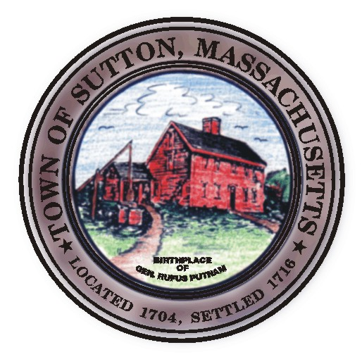
Dr. Steven Rice, Chairman
John Silverberg, Vice Chairman
Diane Miller, Member
William Fredericks, Member
Kenneth Malo Jr., Member
James Malley, PE
Cheryl Rawinski, Public Health Nurse
Christine Fant, Administrative Assistant

TOWN OF SUTTON

Board of Health

Meeting Agenda

July 14, 2009

- 6 Colonial Road, Local Upgrade

- Kings Campground

- 8 West Sutton Road

- Minutes

- Departmental Update

Posted In the Town Clerks Office

July 13, 2009

